NAME __________________________ ALGEBRA 1
DATE ________________ HOMEWORK

Consider the function given by the formula f(x) $=\left\{\begin{aligned}x+1, &x> -1 \\ -x-1, & x ≤ -1\end{aligned}\right.$
- Fill out the table below for the inputs given. Keep in mind which formula you are using.
x | Calculations | y
-3
-2
-1
0
1
2
3

- Graph the function below.
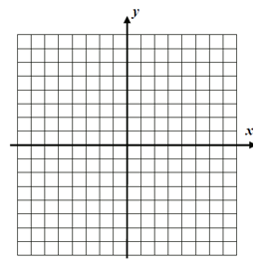

Consider the function given by the formula f(x) $=\left\{\begin{aligned}-2x+8, &x ≤4 \\ \frac{1}{2}x-2, & x>4\end{aligned}\right.$
- Fill out the table below for the inputs given. Keep in mind which formula you are using.

x | Calculations | y

- Graph the function below.

