NAME ____________________________ ALGEBRA 1
DATE ____________________ HOMEWORK
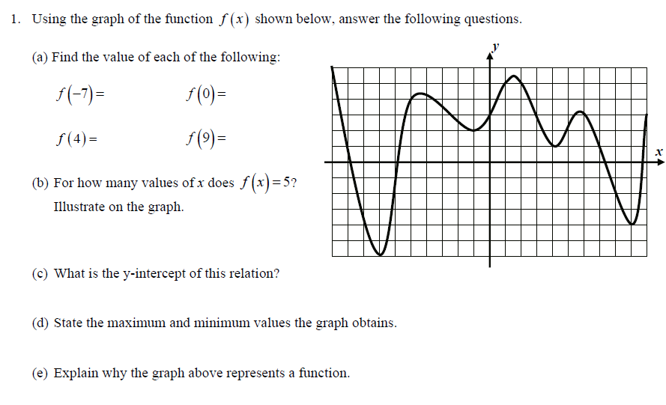

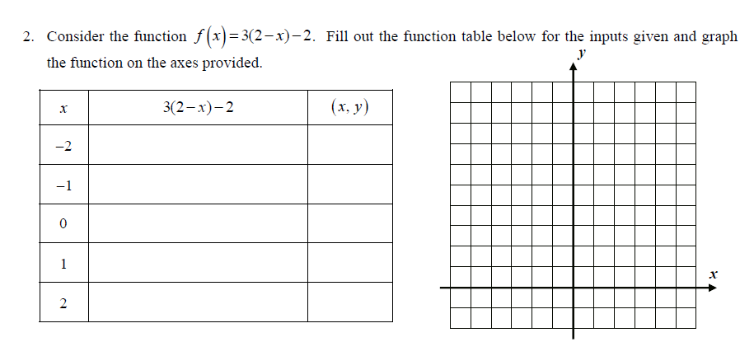

REVIEW QUESTIONS:
- The expression (3x²y⁴)² is equivalent to __________.

- The solutions to the equation 2$\left|x+1\right|-4=6$ are:

- {4, 6} (2) {4, -4} (3) {4, -6} (4) {-4, 6}

